Download ElectriciteVerte_DataAnalysisandValidation file below to use for this activity.
Note: The "ElectriciteVerte_DataAnalysisandValidation" dataset is SIMILAR to the last practice project's Electricite Verte solution but is not the same. Please use the dataset linked below to complete this project.

Task 1
Locate and download the data set you've been given access to. Open it and review the structure of the data (column and row headings).
While reviewing the structure, you'll notice that in the Electricity Supplier column, Scottish Gas is spelled two different ways ("Scottish Gas" and "Scottish G@s"). In both the 2020 and 2021 data, standardise this so there's only one spelling for the company name.
Ctrl and H for find and replace
Question 1: After ensuring consistent spelling of the company name, how many readings were completed by Scottish Gas in 2021?
Format: whole number, e.g. 123
1200 – filtered for Scottish gas then read entry minus 1
Task 2
Your manager wants you to start by exploring the electricity reading trends for each year. Determine the average electricity reading per month for 2020, then repeat for 2021.
2020 = 104.8708583
2021 = 108.8051333
Question 2: What is the lowest monthly average electricity reading in 2020?
Format: two decimal places, no £ sign, e.g. 123.45
48.3
Task 3
Determine the total electricity reading for each month in 2020. Repeat for 2021.
2020 = 125925.02
2021 = 130566.16
Question 3: What is the total electricity reading for all customers in January 2021?
Format: two decimal places, no £ sign, e.g. 123.45
12352.57

Task 4
Now explore the trends for average electricity reading per month, broken down by the three electricity providers. Determine the average electricity reading per month for Scottish Gas, MPower, and SSW in 2020.
Scottish Gas = 104.8501382
MPower = 104.8501382
SSW = 104.8501382

Question 4: What is SSW's average electricity reading for January 2020?
Format: two decimal places, no £ sign, e.g. 123.45
104.8501382

Task 5
While doing your analysis, a coworker suggests using a scatter plot to summarise your data.
Question 5: Which variables would be most appropriate to compare using a scatter plot?
- Customer ID vs. Electricity Reading
- Electricity Supplier vs. Solar Panels
- Reading Year vs. Bedrooms
- Electricity Reading vs. Gas Reading
Task 6
You decide against using a scatter plot for this analysis. The last variable your manager wants explored is how having solar panels impacts consumer energy patterns. Determine the average gas reading and average electricity reading for homes both with and without solar panels in 2020.
Solar panel
Gas = 53.25455809
Electricity = 99.63736029
No solar panel
Gas = 50.35108549
Electricity = 105.5964916
Question 6: True or False - The average gas reading for customers in 2020 was lower for those that had solar panels than for those that did not.
False
Task 7
Create a line chart displaying the average electricity reading for homes both with and without solar panels in 2020, across each month. Be sure to include:
- A chart title
- Axis titles for both the x and y axis
- A y-axis starting point of 70
- A legend

Question 7 [Self Evaluate]: Compare your 2020 chart to the exemplar chart. Does your chart have the following? Choose: Yes / No
- A chart title
- Axis titles for both the x and y axis
- A y-axis starting point of 70
- A legend

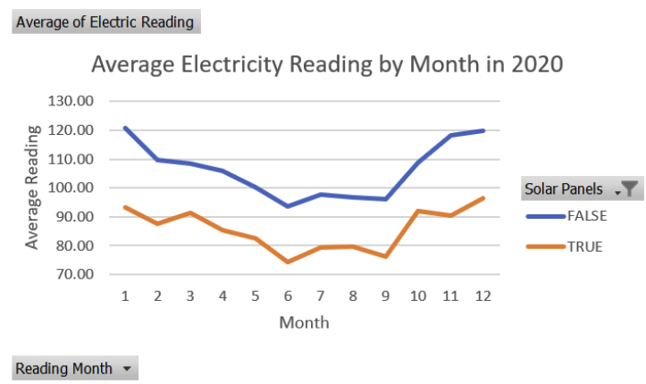

Question 8: How did you apply algorithms and statistical methods to identify trends in the Electricité Verte data? What additional statistical methods could you use to further understand the data?
I Used PivotTables to aggregate the raw meter-reading data (calculating the average electric reading grouped by month and by Solar Panels status), which is a basic statistical method for summarising trends across a categorical grouping. Plotting these averages as a line chart made the seasonal trend visible — readings drop through the warmer months (roughly June–September) and rise in winter, and the "solar panels = TRUE" group consistently sits below the "no solar panels" group across every month.

Additional statistical methods that could deepen this analysis:
- Standard deviation / variance per group, to see how consistent readings are within each month, not just the average.
- Correlation analysis between electric and gas readings (as flagged in your earlier scatter plot question) to see whether higher electricity use tracks with higher gas use.
- Regression analysis to quantify how much solar panels reduce electric readings, controlling for factors like bedrooms or supplier.
- Median and IQR, since averages can be skewed by outliers — worth checking if a few extreme readings are pulling the mean.
- Year-over-year comparison (2020 vs 2021) using the same pivot approach, to see if the trend holds or changes.

Question 9: What steps would you take to ensure the data is clean and reliable before any analysis takes place?
• Check for missing/blank values — you already hit this directly: several rows had a blank Solar Panels field rather than TRUE/FALSE, which silently created a misleading "(blank)" category in the pivot table until filtered out.
• Check for inconsistent data types — for example, one row I spotted in the Gas Reading column had the text "None"instead of a numeric blank or zero, which would need correcting or excluding so it doesn't break calculations.
• Check for duplicate records — e.g. the same Customer ID appearing with different readings.
• Validate ranges — flag readings that are implausibly high, negative, or zero where that doesn't make sense.
• Standardise categorical values — make sure fields like Electricity Supplier don't have inconsistent naming (e.g. "SSW" vs "S.S.W.") that would fragment groupings.
• Confirm date/period fields are correct — e.g. Reading Month values are 1–12 and Reading Year matches the sheet it's on.

Question 10: What were the main challenges you encountered during this task, and how did you overcome them?
• Missing data distorting the pivot table — the blank Solar Panels entries created an extra, meaningless category in both the table and the resulting PivotChart. I overcame this by filtering "(blank)" out directly in the pivot table's Column Labels filter, which removed it everywhere downstream, including the chart.
• PivotCharts inheriting the full field list, not just the selected cells — initially reselecting a narrower range didn't remove blank from the chart, because PivotCharts are linked to the pivot's fields rather than the raw selection. The fix was filtering at the pivot table level, not the chart level.
• Choosing the right chart type for the right comparison — deciding a line chart suited monthly trends over time, while a scatter plot suited comparing two continuous variables like electric vs gas readings.

Question 11: What are the benefits of automating the process of data cleaning and analysis?
• Consistency — automated rules (e.g. always flagging blanks or non-numeric entries) apply the same way every time, removing the risk of manually missing something like the blank Solar Panels rows.
• Speed and scalability — manually building pivot tables and checking for errors works for ~1,200 rows, but automation (scripts, Power Query, macros) scales to much larger datasets without extra manual effort.
• Reduced human error — automated processes cut down on mistakes like typos, wrong cell ranges, or forgetting to filter/refresh.
• Repeatability — if this analysis needs to be rerun each year with new data (e.g. a 2022 sheet), an automated pipeline can reproduce the same cleaning and pivot logic without rebuilding it from scratch.
• Frees up time for higher-value analysis — automating the cleaning/aggregation steps leaves more time for interpreting trends and drawing insights, rather than manually wrangling data.

